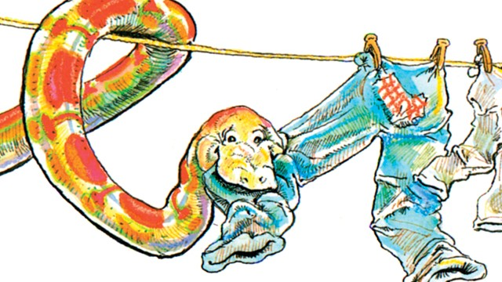

**Who**: Attention all 2nd and 3rd graders

**What**: Trinka Hakes Noble writing/drawing activity

Amazing author and illustrator, Trinka Hakes Noble, will be visiting our school on March 21, 2013. Let’s celebrate her arrival with an activity inspired by her beloved “Jimmy’s Boa” series! Jimmy’s Boa is always having outrageous adventures! If you had a pet boa, what mischief might it get into? Choose one adventure your boa might have, draw a picture and write a paragraph about it.

**When**: Please submit your drawing and paragraph by Tuesday, March 12, 2013

**Where**: Submit your entry to Mr. Mullarkey in the library.

**Why**: To celebrate the arrival of author/illustrator Trinka Hakes Noble and earn the chance to share dessert with her! All students who complete this activity will be entered into a drawing, and several students will be selected randomly to have dessert with Ms. Noble.

Please be sure to include your name and grade!